Friends of Chitambo
Future Plan 5 Years 2023-2028

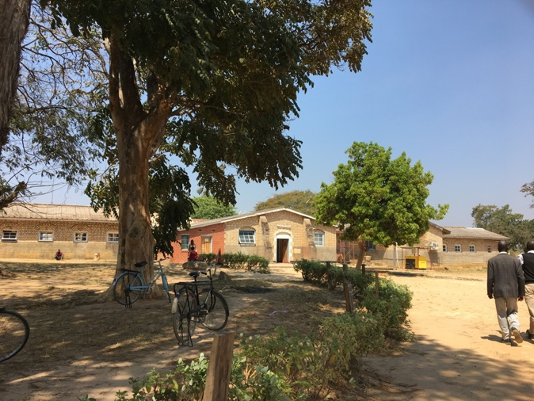

Who we are

Friends of Chitambo (FoCH) is a volunteer run organization, founded in 2011, following a revisit to Chitambo hospital, a few years earlier, by descendants of Scottish medical missionaries who had lived and worked there.

Our aim is to advance health in the Chitambo District by supporting health measures in the hospital and surrounding district by responding to issues raised by the local staff.

Our Principles & Approach

- Maintaining a close and supportive relationship with the Chitambo community

- Attempting to meet the needs of the most disadvantaged

- Driven by needs identified by local partners, and taking time to establish the best approach.

- Ensuring that the wellbeing and safety of all involved is taken into account at all times

- Being open to innovative solutions

- Recognising the significant impact of skill training on the community

- Collaborating with other organisations with shared objectives

- Abiding by our equal opportunities policy in all that we do

- Working towards Sustainable Development Goals. This includes:

2. End hunger: achieve food security and improved nutrition’

3. Health - particularly:
3.1 reduce maternal mortality rate
3.2 end preventable deaths of newborns and under 5s
3.6 reduce the number of deaths and injuries from road accidents

4. Ensure inclusive, equitable education and promote life-long learning

6. Availability and sustainable management of water and sanitation.

7. Access to affordable reliable and sustainable clean energy

17. Global partnership for sustainable development

Healthcare in Chitambo District

Chitambo District is located in the Northeast of Central Province, Zambia.
Chitambo Hospital was founded in 1908 by the family of Mary Moffat, the wife of David Livingstone, who died nearby. Originally run by Church of Scotland missionaries, including relatives of the FoCH founder, it is now under the control of the Zambian Ministry of Health (MOH)
It serves a large rural area with a population estimated at over 100,00, of which half are under the age of 15. Their income is mainly from subsistence farming and fishing.
Main roads carry long distance buses and trucks from Tanzania and DR Congo, and are the source of frequent accidents, often with multiple casualties.
The small 100 bed hospital is a hub for 19 rural health clinics (RHC), including 2 ‘mini-hospitals’; some are over 150km from the hospital along unpaved floodable roads, close to the Bangweulu wetlands. Ideally each RHC is staffed by a minimum of a clinical officer, a nurse/midwife, a public health technician and a community domestic employee (who has limited basic health training but can be the sole staff at a clinic and have to deal with emergencies, deliveries etc). The hospital staff includes 3 doctors and an anaesthetist.
The nearest Level 3 hospital, with trauma centre is in Kabwe, ….km away

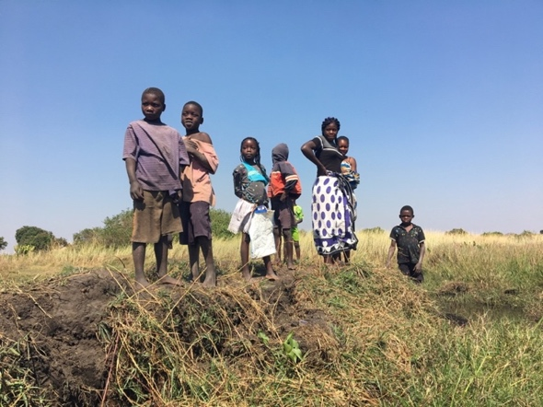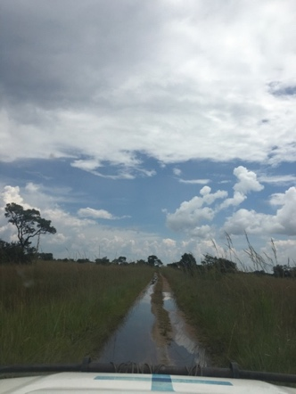

What we do

Friends of Chitambo (FoCH) supports health-related projects in Chitambo District.
Members were previously involved in reopening the School of Nursing and providing an ambulance, which we continue to maintain.

Friends of Chitambo:
- Provides scholarships at Chitambo School of Nursing for four underprivileged student nurses.
- Provided and maintains an ambulance
- Has increased communication between clinics, hospital and ambulances via VHF radios
- Has facilitated courses in first aid and emergency care for both staff and community
- Has provided books and computer tablets for staff study.
- Provided PEP during the pandemic
- Provides support for members of staff undergoing further training.
- Facilitated the provision of an oxygen generator and pipelines to bedsides
- Facilitates visits by specialist clinicians
- Is working to create a link between Chitambo and NHS South Lanarkshire

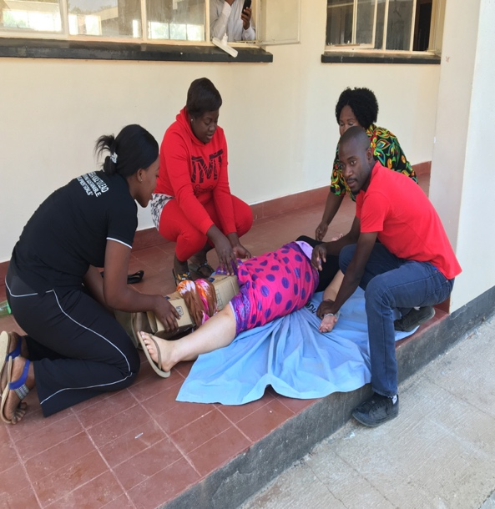l

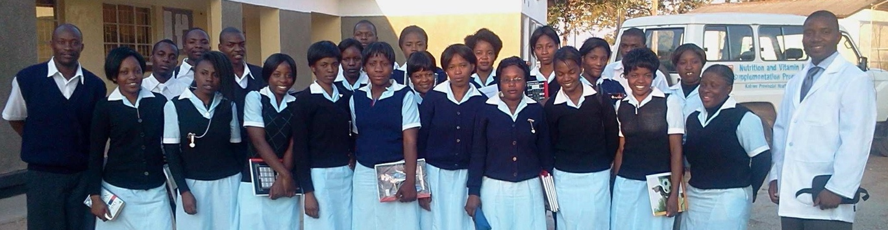

Strategy for the next 5 years

Organisational development

In line with general views that control of organisations should be transferred to the Global South, Friends of Chitambo is creating a separate Zambian organizational partner.

This will involve:

- FoCH Zambia to increase ownership of the organization

- FoCH UK board reducing Zambian responsibilities and activities to concentrate on brokering meaningful relationships, such as for training opportunities and fundraising

- Establishing responsibilities to be devolved to each organisation

- Developing UK/Zambia Partnership Agreement

- Reviewing the existing constitution and application to each organization

- Reviewing existing policies and applying them to each organization

- Zambian Board to set own objectives and roles, including appointment of key office bearers

- Considering employing an in-country co-ordinator

Medical Priorities

Priorities are determined in consultation with Chitambo health staff.
It is important that there is awareness of and alignment with Zambian Ministry of Health (MOH) plans. Currently all FoCH activities are aligned with government priorities.

The Zambian National Health Service Strategic Plan 2022-2026 recognises constraints on available resources and capabilities, and is prioritizing prevention i.e. Primary Health Care and Health Promotion.

Maternal Health

Although the maternal mortality ratio (MMR) has reduced over the past few years, to 378/100,000 live births in 2018, it is nowhere near the target of 100. (by comparison UK MMR was 11.7 in 2019-21)
The neonatal mortality rate (NMR) has hardly dropped at all.
Measures proposed by MOH to reduce these rates include:
- Strengthening integrated people-centred health service delivery
- Extending infrastructure of maternity annexes
- Strengthening community sensitization on danger signs of pregnancy and the benefits of institutional delivery

In keeping with MOH Strategic Plan to reduce MMR and NMR, FoCH recognizes the urgent need in Chitambo for:
- Mothers’ shelters where expectant mothers can stay prior to delivery, especially if they have high risk pregnancies and are living far away
- Repairs to current maternity unit
- Utimately a completely new maternity unit

Neonatal Health

- Improved maternal care should reduce the incidence of neonatal death
- Need for resuscitation equipment for the newborn
- Possibility of facilitating specialized neonatal courses for midwives

Emergency care

Chitambo Hospital is next to the Great North Road, carrying heavy trucks from the Tanzanian coast and long distance buses. There are frequent multi-casualty accidents requiring attention.
FoCH intends continuing provision of further Emergency Care and First Aid training

Malaria

Much of Chitambo District is located next to the Banguela Wetlands, which has a high rate of malaria.
This could be helped by education of community and health care staff.

Under 5s nutrition

There is a high rate of childhood malnutrition in the district, and there is a recognised need for:
- Education of health staff in recognition and treatment of acute and chronic childhood malnutrition.
- Sensitisation of parents to childhood nutrition needs and recognition of malnutrition
- Establishing Community gardens

Current Projects

Maternity
- Mother’s waiting shelter
Plans are in progress to build a shelter in the grounds of Chitambo Hospital to house women in the last weeks of pregnancy, awaiting labour. This is particularly important for those with complicated pregnancies and/or living far away.
This will comprise a facility for 20 pregnant women plus their carers.
It will include showers, toilets, beds, lockers, and a cooking area.
It is to be built, furnished and functional by the end of the term.

Management
- Establishment of an international steering committee
- Establishment of a Chitambo based steering committee, including those with technical and local knowledge
- Establishment of a Monitoring and Evaluation committee, including local and international members
- Approval of Bill of Quantity (BOQ)
- Establishment of a dedicated bank account

Finance
- Two New Zealand sources have pledged a large proportion of the required funds
- A Scottish Charitable organization has pledged a considerable funds
- Funds have been raised through an online appeal and various Zambian and Scottish fundraising activities
- Contribution of bedding to be provided by a Zambian charitable organisation
- Explore the potential for Zambian Government to contribute through Community Development Fund (CDF)
- Explore public/private finance

- Further shelters at other health facilities may be considered, once the Chitambo Shelter is established

- New Maternity Unit. The need for a new maternity unit has been highlighted by the District Medical Director, and FoCH may consider helping to facilitate this in the future
Oxygen Generator

- The Oxygen Generator, provided by the Scottish Government has been installed at Chitambo Hospital, and is fully operational, including the pipeline leading to bedsides and the operating theatre, contributed by FoCH’s fundraising efforts.
- A system for monitoring is to be finalised.
- A maintenance programme is to be finalised
- A system for financial stability involving profits from sale of oxygen to other facilities ist o be established
- Plaques are to be erected to acknowledge the contributions by various parties

Health Care Education and Training

FoCH will continue to:
- Fund and manage nursing scholarships
- Support individual members of staff in further training where appropriate
- Organise and facilitate courses in specialist topics
- Continue to be involved in developing the link between NHS South Lanarkshire and Central Province, particularly Chitambo District
- Explore possibility of midwifery mentoring and exchange via link with NHS Lanarkshire
- Continue to facilitate visiting specialists

Ambulance

FoCH will continue to maintain the centenary ambulance

