Article for Informatics in Primary Care

The Twinning of Scottish General Practices and Malawian Clinics: The Provision of E-mail and Internet Services

Ron Neville – GP at Westgate Health Centre, Dundee, Scotland
Sam Riddell – Practice Director, Westgate Health Centre, Dundee, Scotland
Pam Wilson – Former Westgate Health Centre District Nurse on VSO as Clinical Nurse Tutor, Zomba, Malawi
Paul Nkhoma – Project Ambassador, Blantyre, Malawi

Correspondence:

Ron.Neville@blueyonder.co.uk

Abstract

Many patients and health care professionals in the developed world are uncomfortable about doing nothing in the face of the glaring inequities in health care between their own environment and that of Africa. In an effort to ‘think global, act local’ a Scottish GP practice used personal contacts to build a twinning link with a clinic serving a township in Malawi. This article describes the experience of establishing e-mail and internet services for Malawian health care staff to afford them the same level of access as developed world staff enjoy in accessing educational materials and professional supports. Using our twin link as an exemplar we are now matching other Scottish General Practices to Malawian Clinics around a common theme of modern communication media.

Why did we become involved?

In the face of the African debt burden, the HIV problem, and a continual stream of negative media stories to emerge form Africa we felt ‘doing nothing’ was no longer an option. The public NHS in Scotland and private care home facilities are increasingly benefiting from the influx of skilled health care workers from Africa. This flow of talented people is a further exodus from resource poor Africa to the resource rich west. As a Scottish NHS General Practice we felt we had a moral responsibility to ponder for a moment, consider our options, and try to do something practical to make the relationship between the people of Africa and the people of Scotland more equitable. We considered a range of options and decided to follow the World Health Organisation mantra to “think global, act local”. Our global mission was thus to help our health care colleagues in Africa, and our local task to find a clinic to twin with.

The Scotland Malawi Partnership?

The people of Scotland and the people of Malawi have many links going back to the time of David Livingstone. Recently the First Minister of Scotland and the President of Malawi signed a partnership agreement to work together. Under the broad umbrella of the Scotland Malawi Partnership a series of projects working with schools, hospitals and aid projects have been set up.

http://www.scotland-malawipartnership.org/

We thought the idea of twinning Scottish GP practices and Malawian Clinics would give health care workers in Scotland and in Malawi and chance to share experiences and help each other on an equal and equitable basis. Rather than follow the traditional path of fund raising for hospitals, orphanages or Non Government Organisations (NGO) we opted for a low key approach to establish people links first, and see how we could help each other. We planned to proceed slowly, respecting local traditions, to build a dialogue between health care workers in Scotland and Malawi in a long term low key sustainable way.

Choosing a clinic

A district nurse (PW) from Westgate Health Centre on a Volunteer Service Organisation (VSO) placement in Zomba, Malawi met with a personal contact of one of the practice GPs (PN) in Blantyre. PW and PN visited a series of clinics in Southern Malawi. Private and NGO clinics invariably had an agenda including one way receipt of more aid, or the optimistic hope we had come to pay off their debts. In contrast the Ministry of Health clinics we visited offered a chance for us to work alongside existing services in a two way long term relationship. We chose Zingwangwa Clinic which serves the 110,000 people in a township adjacent to Blantyre. The clinic tries to manage a full range of health conditions, but in a resource poor environment, without resident medical staff. Westgate Health Centre Dundee serves an urban population of 11,000 people, has eight medical partners and a full range of support staff and equipment.

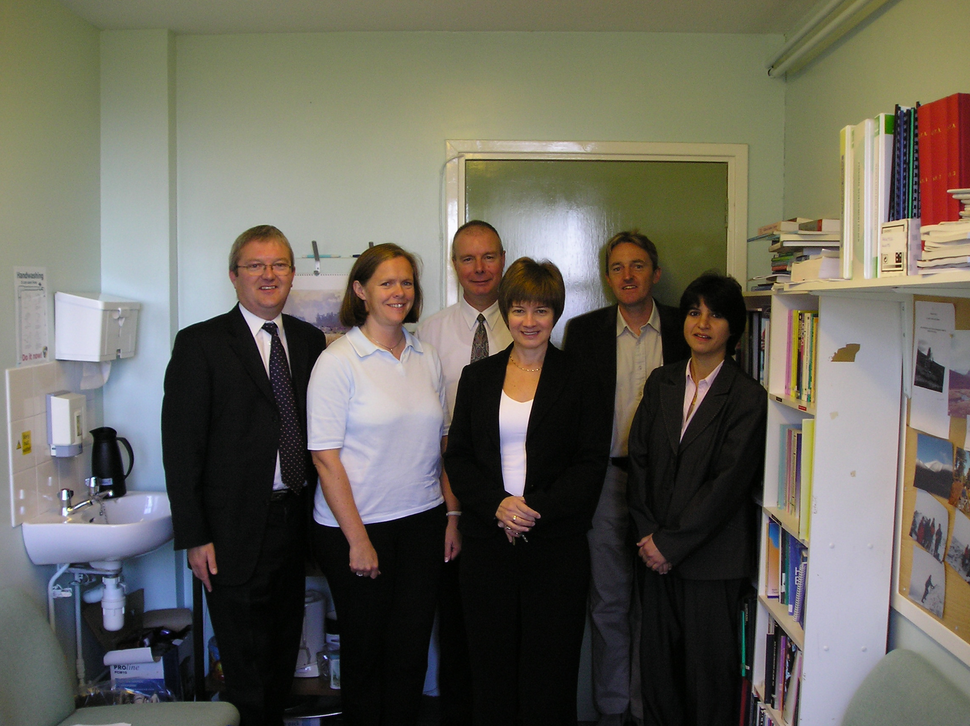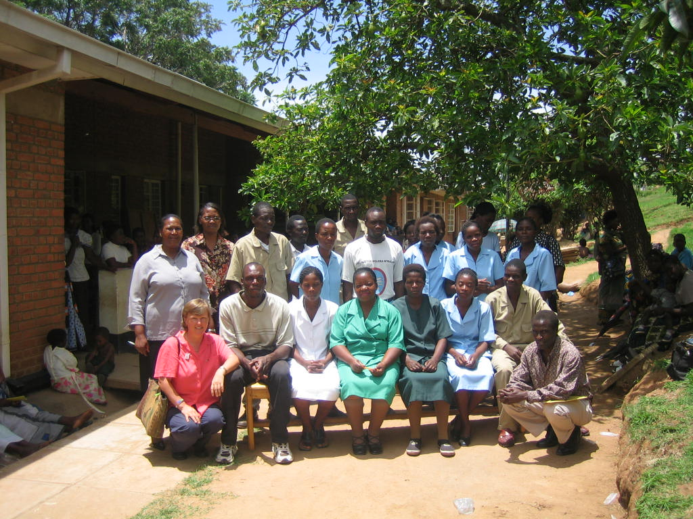

Twinning network

We were successful in a bid to the Scotland Malawi Partnership to try to develop a network of 20 Scottish Practices twinned with 20 Malawian Clinics, based around a theme of access to technology to improve healthcare. The Westgate, Dundee and Zingwangwa, Blantyre link is being used as an exemplar to offer other practices and clinics the chance to work together and share experiences. Westgate has helped to pioneer the introduction of e-mail and SMS access to clinical services and encouraged staff and patients to use of the internet. We felt that offering the same range of modern ‘high tech’ services to the staff and patients at Zingwangwa would make the experience of working at Zingwangwa rewarding and encourage staff to stay serving their local community.

http://zingwangwa.googlepages.com/

Wish list

A staff meeting in Scotland concluded that the best way we could support and learn together with our colleagues in Malawi would be to provide the staff at Zingwangwa with access to a full range of medical and nursing journals, together with patient educational materials. A reciprocal meeting in Malawi highlighted the need for basic medical equipment and a means to communicate with each other and with Scotland. A state of the art lap top computer and digital camera was thus placed top of the ‘equipment list’.

A technical partner in Africa

We felt providing e-mail and internet services to Zingwangwa should be an early priority. After an extensive search, testing of help lines, and a technical survey, we contracted a Malawian company to install signal boosting equipment, transmitter and all the necessary equipment to allow broadband internet to reach the clinic, situated in a hollow behind a hill.

http://www.globemw.net/

After series of polite negotiations resolved by our Malawian project Ambassador (PN), signal boosting, and the erection of a large mast in the midst of the rainy season, our connection was established. We deliberately chose a wireless broadband system and are hopeful that local schools and businesses take advantage of the opportunity to use our signal to obtain free broadband internet.

‘Malawian cheer’

Malawian TV filmed the handover of computing equipment at Zingwangwa. The staff from Westgate watched a clip of this. The joyful celebration from Malawian staff has led Scottish staff to adopting a ‘Malawian cheer’ for any favourable announcements from our managerial staff.

E-mails

Scottish staff have delighted in receiving e-mails form their Malawian colleagues. Many of these e-mail begin with “hello, this is my first e-mail…”
In time health care staff, nurses and midwives at Zingwangwa will use e-mail to share clinical experiences and seek advice and support, and vice versa. We are looking at the feasibility of equipping colleagues in Malawi with mobile phones. SMS/text messaging is an inexpensive way of communicating in remote a rural Africa where land lines are often unreliable or non-existent.

Journals on line

We have made a link to the WHO Hinari site, accessible to health care staff in Malawi. This allows access to most of the worlds medical and nursing journals, free, on line.

http://www.who.int/hinari/en/

It is important for health care staff to be able to keep up to date and share learning experiences with their colleagues without having to migrate to cities, or move abroad to enhance skills.

Prevention of Corruption?

We have appointed a Project Ambassador in Malawi (PN) to personally oversee the smooth running of the project and to act as our ‘eyes and ears’. We have found that employing a respected figure in the local community allows us to develop the project is a sustainable way, working within the traditions and sensibilities of Malawian culture. PN is able to meet with politicians, clinic administrators and suppliers to make sure all aspects of the project are integrated with Malawian Ministry of Health priorities and respect local sensibilities. It is vital that we can demonstrate that every UK pound or Malawian Kwatcha spent is spent well.

Photo diary

A core theme of our project is for the people of Scotland to learn and share experiences form the people of Malawi. We have constructed a series of ‘photo diaries’ for staff and patients in Scotland and Malawi. Participants must supply a digital photograph of themselves, state one thing they do that is good for their health or for that of others, and state one aspect of health they would like to improve. In time this should become a common currency for people to share their views and experiences. An early emergent theme is that people in Scotland miss having extended family support, and struggle with excess nutritional intake. Preliminary reaction to this initiative in Malawi supports the view that a person’s story, cultural background and village contacts are integral to their understanding of health and well being. In time we hope groups of staff and patients in Scotland and Malawi will meet and discuss things they do that are good for health, and things they can individually and collectively change.

http://zingwangwa.googlepages.com/staffphotodiary

Join us?

If you work in Scotland or Malawi and would like a twin, let us know and we shall match you with a suitable clinic. We can help with setting up the basics of e-mail and SMS infrastructure for you. You can then choose how best to help each other in a long term low key sustainable way.

